[Skip to content](https://www.safaribooksonline.com/library/view/software-test-engineering/9780137036455/ch12.html" \l "container)

* [*Safari*](https://www.safaribooksonline.com/home/)
* [Recommended](https://www.safaribooksonline.com/r/)
* [Queue](https://www.safaribooksonline.com/s/)
* [Search](https://www.safaribooksonline.com/library/view/software-test-engineering/9780137036455/ch12.html)
* [Expand Nav](https://www.safaribooksonline.com/library/view/software-test-engineering/9780137036455/ch12.html)
  + [Recent](https://www.safaribooksonline.com/recent/)
  + [Topics](https://www.safaribooksonline.com/t/)
  + [Highlights](https://www.safaribooksonline.com/u/p253751/)
  + [Settings](https://www.safaribooksonline.com/u/)
  + [Feedback](mailto:feedback@safaribooksonline.com)
  + [Sign Out](https://www.safaribooksonline.com/accounts/logout/)
  + [Settings](https://www.safaribooksonline.com/u/)**10** days left in your trial. [Subscribe](https://www.safaribooksonline.com/subscribe/).
  + [Feedback](mailto:feedback@safaribooksonline.com)
  + [Sign Out](https://www.safaribooksonline.com/accounts/logout/)

[Software Test Engineering with IBM Rational Functional Tester: The Definitive Resource](https://www.safaribooksonline.com/library/view/software-test-engineering/9780137036455/ch12.html)

* [Search in book...](https://www.safaribooksonline.com/library/view/software-test-engineering/9780137036455/ch12.html)

Top of Form

Bottom of Form

* [Toggle Font Controls](https://www.safaribooksonline.com/library/view/software-test-engineering/9780137036455/ch12.html)
* [Share this](https://www.safaribooksonline.com/library/view/software-test-engineering/9780137036455/ch12.html)
  + [Twitter](https://twitter.com/share?url=http://www.safaribooksonline.com/library/view/software-test-engineering/9780137036455/ch04.html&text=Software%20Test%20Engineering%20with%20IBM%20Rational%20Functional%20Tester%3A%20The%20Definitive%20Resource&via=safari)
  + [Facebook](https://www.facebook.com/sharer/sharer.php?u=http://www.safaribooksonline.com/library/view/software-test-engineering/9780137036455/ch04.html)
  + [Google Plus](https://plus.google.com/share?url=http://www.safaribooksonline.com/library/view/software-test-engineering/9780137036455/ch04.html)
  + [Email](mailto:?subject=Safari:%20Chapter%204.%20XML%20and%20Rational%20Functional%20Tester&body=http://www.safaribooksonline.com/library/view/software-test-engineering/9780137036455/ch04.html%0D%0Afrom%20Software%20Test%20Engineering%20with%20IBM%20Rational%20Functional%20Tester%3A%20The%20Definitive%20Resource%0D%0A)

[Prev](https://www.safaribooksonline.com/library/view/software-test-engineering/9780137036455/ch11.html)

[Chapter 11. Testing Specialized Applications](https://www.safaribooksonline.com/library/view/software-test-engineering/9780137036455/ch11.html)

[Next](https://www.safaribooksonline.com/library/view/software-test-engineering/9780137036455/ch13.html)

[Chapter 13. Building Support for New Objects with the Proxy SDK](https://www.safaribooksonline.com/library/view/software-test-engineering/9780137036455/ch13.html)

**Chapter 12. Extending Rational Functional Tester with External Libraries**

**Larry Quesada, Daniel Gouveia, Marc van Lint**

*Rational Functional Tester is much more than a record and playback automated testing tool. Because Rational Functional Tester is based on industry standard, object-oriented programming languages, you can extend its capabilities in powerful ways. One way you do this is to leverage open source libraries. This chapter covers examples of how to extend Rational Functional Tester to:*

• *Test PDF files using PDFBox, google-diff-match-patch libraries, and IKVM.NET.*

• *Create a custom logging solution using log4j and log4net.*

• *Create an Excel® reporting utility using Jawin and Microsoft Interop libraries.*

*Examples are provided in both Java and .NET.*

**Testing PDF Files**

Many applications today generate reports in PDF format. PDF files don’t readily expose their information, requiring the Adobe Acrobat Reader software to view them. This presents a challenge to many automation tools. The Acrobat Reader is akin to a box, hiding the information that it contains. Test automation tools can see only the box, not what is in it. The good news for automation engineers using Rational Functional Tester is there is an open source package that can access the information in PDF files. This package is so aptly named PDFBox. You can access the text of a PDF file from a Rational Functional Tester script by calling the PDFBox methods for loading PDF files and extracting data from them. In this section, you learn how to use PDFBox to create a custom verification point (VP), which compares the text of two PDF files. You use an open source package called google-diff-match-path to compare the two blocks of plain text. For the .NET version of the verification point, you use a third open source package called IKVM.NET to convert the Java JAR files to .NET assemblies.

To use this verification point, you create a test script and set the helper super class to be the class PdfBoxHelperSuperClass. The verification points for PDF text you create in your test script look and feel like any other Rational Functional Tester verification points. The example test script, shown in [Listing 12.1](https://www.safaribooksonline.com/library/view/software-test-engineering/9780137036455/ch12.html#ch12ex01), uses the new verification point to compare two PDF files. These files differ in that the expected PDF file uses RFT and the actual PDF file sometimes uses Rational Functional Tester. Further, the PDF file contains the current date in the footer and this date is different in the two files. The test script runs the test twice. The first verification point is a straight comparison. The second verification point uses a mask to ignore dates. Both verification points fail, but the second verification point does not mark the dates in the footer as a difference.

**Listing 12.1** Example PDF compare test script

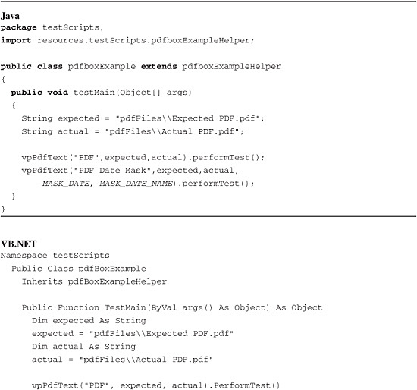

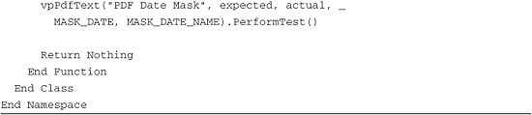

[Figures 12.1](https://www.safaribooksonline.com/library/view/software-test-engineering/9780137036455/ch12.html#ch12fig01) and [12.2](https://www.safaribooksonline.com/library/view/software-test-engineering/9780137036455/ch12.html#ch12fig02) show the results of running the pdfBoxExample test script. You can graphically see the differences between the text of the expected and actual PDF files. In the results of the first verification point, the date in the footer is marked as a difference. In the results of the second verification point, the date in both the expected and actual text is replaced with the text ***MM/DD/YYYY*** and is not marked as a difference.

**Figure 12.1** Test log for pdfBoxExample—PDF verification point

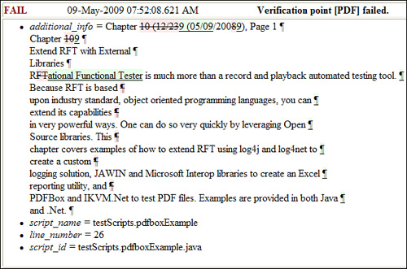

**Figure 12.2** Test Log for pdfBoxExample—PDF Date Mask verification point

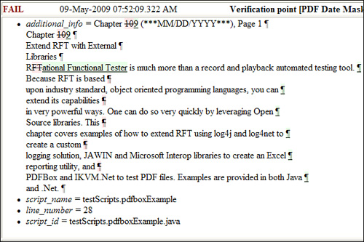

**Setting Up the PDFBox Example for Rational Functional Tester Java**

Follow the instructions in this section to set up the PDF compare example for Rational Functional Tester Java. You can download the example code from [www.ibm.com/developerworks/rational/library/09/testengineeringrft/index.html](http://www.ibm.com/developerworks/rational/library/09/testengineeringrft/index.html). Unzip the file Chapter12.zip into a directory. The setup steps assume you unzipped into the directory C:\.

**Importing the Example into an Existing Project**

Follow these instructions to import the example into an existing project:

**1.** Create a new Rational Functional Tester project (or use an existing one).

**2.** From RFT, select **Import** from the File menu.

**3.** In the Import dialog box, expand the Other folder and select **Functional Test Project Items** (see [Figure 12.3](https://www.safaribooksonline.com/library/view/software-test-engineering/9780137036455/ch12.html#ch12fig03)).

**Figure 12.3** Import Rational Functional Tester Java project items

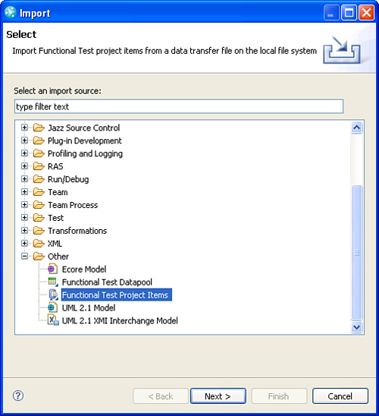

**4.** Select **Next**.

**5.** Next to **Transfer File**, select the file **pdfBox.rftjdtr** from the directory \Ch12 Downloads\RFT Java.

**6.** Under **Select the import location**, select the destination RFT Java project (see [Figure 12.4](https://www.safaribooksonline.com/library/view/software-test-engineering/9780137036455/ch12.html#ch12fig04)).

**Figure 12.4** Import pdfBox.rftjdtr

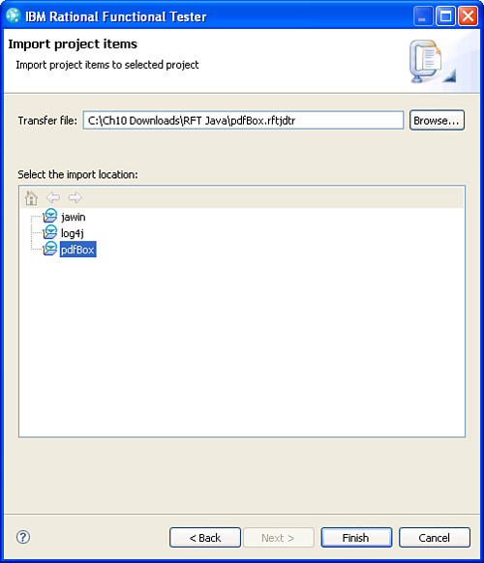

**7.** Select **Finish.**

**Configuring the RFT Java Project to Use PDFBox**

To set up PDFBox in a new RFT Java project, you add a reference to the PDFBox JAR files (PDFBox-0.7.3.jar and FontBox-0.1.0-dev.jar) in the Java Build Path of your RFT Java project. You can either download them from the Apache Software Foundation ([www.pdfbox.org](http://www.pdfbox.org/)) or you can use the JAR files contained in the transfer file you just imported. Follow these instructions:

**1.** Right-click on your RFT Java project and select **Properties.**

**2.** In the **Properties** dialog box, select **Java Build Path** and then select the **Libraries** tab (see [Figure 12.5](https://www.safaribooksonline.com/library/view/software-test-engineering/9780137036455/ch12.html#ch12fig05)).

**Figure 12.5** The Java Build Path

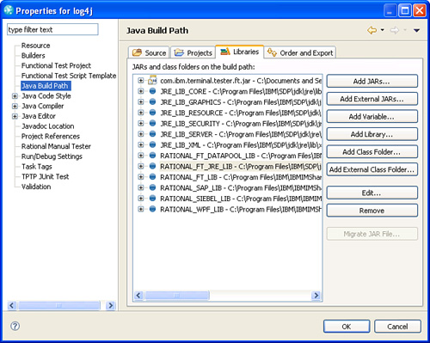

**3.** Select the **Add External JARs** button.

**4.** Navigate to the **jars** directory in your RFT Java Project. Select the JAR files **PdfBox-0.7.3.jar** and **FontBox-0.1.0-dev.jar**.

**5.** Select **OK.**

**Configuring the RFT Java Project to Use google-diff-match-patch libraries**

Google packages google-diff-match-patch libraries as source code, which you can download from <http://code.google.com/p/google-diff-match-patch>. To use it, you need to either import the source code into your RFT Java project or create a JAR file and reference the JAR file. A JAR file called google-diff-match-patch.jar in the transfer file you imported is provided. It is in the folder called jars. You can use it by adding it to the Java Build Path of your project. Follow the instructions outlined previously to do so.

**Setting Up the PDFBox Example for RFT .NET**

Follow the instructions in this section to set up the PDF compare example for RFT .NET. You can download the example code from [www.ibm.com/developerworks/rational/library/09/testengineeringrft/index.html](http://www.ibm.com/developerworks/rational/library/09/testengineeringrft/index.html). Unzip the file Chapter12.zip into a directory of your choosing. The setup steps assume you unzipped into the directory C:\.

**Importing the Example into an Existing RFT .NET Project**

Follow these instructions to import the example into an existing RFT .NET project:

**1.** Create a new RFT .NET project (or use an existing one).

**2.** In the **Solution Explorer** view, right-click on your project and select **Import**.

**3.** In the **Select Data Transfer File** dialog box, select the file **pdfbox.rftvdtr**. It is in the directory C:\Ch12 Downloads\RFT .NET\.

**4.** Select **Finish**.

**5.** Copy the folders **pdfFiles** into the RFT .NET Project directory. This folder is located in the file C:\Ch12 Downloads\RFT .NET\pdfBox.zip. Your project should appear as shown in [Figure 12.6](https://www.safaribooksonline.com/library/view/software-test-engineering/9780137036455/ch12.html#ch12fig06).

**Figure 12.6** RFT .NET project after importing PDFBox example

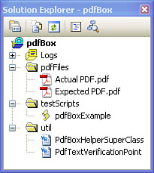

**Configuring the RFT .NET Project to use PDFBox**

Because PDFBox does not support .NET, you need to convert the Java libraries to .NET assemblies. You do this using an open source project called IKVM.NET. IKVM provides tools to enable Java and .NET interoperability. Alternatively, you can find the converted libraries in the file C:\Ch12 Downloads\RFT .NET\assemblies.zip. The assemblies you want are called PDFBox-0.7.3.dll and FontBox-0.1.0-dev.dll.

You also need several additional IKVM assemblies to run the Java code in .NET. You can download these from the IKVM site ([www.ikvm.net](http://www.ikvm.net/)). They are also provided in the assemblies.zip file:

• ..\ikvm\bin\IKVM.Runtime.dll

• ..\ikvm\bin\IKVM.OpenJDK.ClassLibrary.dll

• ..\PDFBox\bin\IKVM.GNU.Classpath.dll

To create references from your RFT .NET project to the assemblies just discussed, perform the following tasks:

**1.** Copy PDFBox-0.7.3.dll, IKVM.OpenJDK.ClassLibrary.dll, and IKVM.GNU.Classpath.dll into the RFT customization directory (C:\Documents and Settings\All Users\Application Data\IBM\RFT\customization).

Rational Functional Tester loads them when it launches, providing your test project access to their contents.

**2.** Copy PDFBox-0.7.3.dll, FontBox-0.1.0-dev.dll, IKVM.GNU.Classpath.dll, IKVM. Runtime.dll, and IKVM.OpenJDK.ClassLibrary.dll into the bin directory located in your RFT .NET project.

This enables the DLLs to find each other and, more specifically, their objects and methods, at runtime.

If you want to convert the Java JAR files to .NET assemblies, you need a tool called IKVMC, which you can find in the bin directory of the download of IKVM. From a command line, run the following commands to complete the conversion:

C:\> C:\ikvm\bin\ikvmc -target:library PDFBox-0.7.3.jar  
C:\>  C:\ikvm\bin\ikvmc -target:library FontBox-0.1.0-dev.jar

These commands assume the current directory of the command line contains all of the JAR files to convert and outputs the files PDFBox-0.7.3.dll and Fontbox.0.1.0-dev.dll. Note that the PDFBox download contains versions of the PDFBox and FontBox assemblies, but do not use these because they are not compatible with the google-diff-match-patch assembly.

**Configuring the RFT .NET to Use google-diff-match-patch libraries**

Like PDFBox, google-diff-match-patch libraries does not support .NET. You need to convert the Java libraries to .NET assemblies. You find the converted assembly in the file C:\Ch12 Downloads\RFT.NET\assemblies.zip. The assembly you want is called diff-match-patch.dll. Copy it into the RFT customization directory (C:\Documents and Settings\All Users\Application Data\IBM\RFT\customization) and the bin directory of your project. Finally, restart Rational Functional Tester.

If you are not using the assembly supplied with the chapter download, run the following command to complete the conversion. We provide the google-diff-match-patch.jar file in the transfer file C:\Ch12 Downloads\RFT Java\pdfBox.rftjdtr.

C:\>  C:\ikvm\bin\ikvmc -target:library google-diff-match-patch.jar

This command assumes the current directory of the command line contains the JAR file to convert and outputs the file google-diff-match-patch.dll.

**Understanding the Code**

The solution consists of several parts. Most of the work is done in a class called PDFTextVerificationPoint. It represents the verification of the text of a PDF file. In addition to extracting the text from the PDF file using the PDFBox classes, this class implements the IFtVerificationPoint interface. It provides methods such as performTest and compare, which use the Diff Match Patch classes to intelligently compare the text of the expected and actual PDF files. To account for text that would always differ between to PDF files, such as a date, you can provide a mask. We use regular expressions to implement the mask. The performTest and compare methods ignore any text, which match the regular expression. There is also a class called PdfBoxHelperSuperClass. This helper super class has methods and constants that make it simple to create a PDF text verification point in a test script. See [Figure 12.7](https://www.safaribooksonline.com/library/view/software-test-engineering/9780137036455/ch12.html#ch12fig07).

**Figure 12.7** pdfBoxExample class diagram

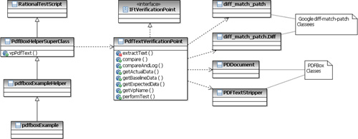

The rest of this section describes how the PDF verification point works. The PdfTextVerificationPoint class is reviewed first, and then the PdfBoxHelperSuperClass.

**Import Statements**

You need to import a number of libraries in the PdfTextVerificationPoint class to easily access methods from PDFBox, google-diff-match-patch libraries, IftVerificationPoint, and some utility classes. Refer to [Listing 12.2](https://www.safaribooksonline.com/library/view/software-test-engineering/9780137036455/ch12.html#ch12ex02).

**Listing 12.2** Import statements

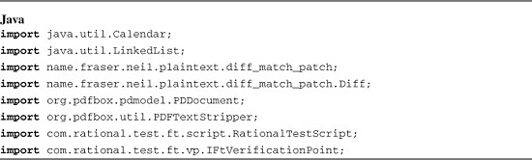

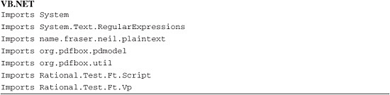

**Data Members and Constructors**

The PdfTextVerificationPoint class keeps track of a number of data items. It has a verification point name, expected text, and actual text. Of course, it also needs to keep track of the location of the expected PDF file and the actual PDF file. Finally, the PdfTextVerificationPoint has a mask and a mask name. A *mask* is a regular expression that represents text that should be ignored during a comparison. The mask name is used in place of all text that matches the mask. A good example is the current date. If the current date appears in the expected and actual PDF files, you don’t want the verification point to fail when the dates differ because they may always be different. By replacing all instances of the date (as defined by the mask regular expression) with the mask name, the verification point effectively ignores all dates in the two files.

The PdfTextVerificationPoint class has two constructors. One of the constructors passes in a mask and mask name, and the other does not. Both constructors update member data with the passed in parameters and call a method called extractText to extract the text from the expected and actual PDF files. Refer to [Listing 12.3](https://www.safaribooksonline.com/library/view/software-test-engineering/9780137036455/ch12.html#ch12ex03).

**Listing 12.3** Data members and constructors

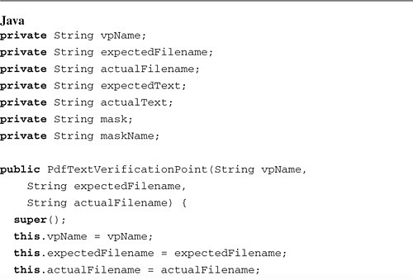

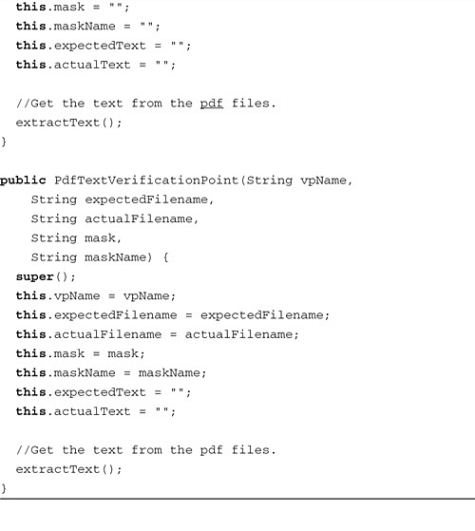

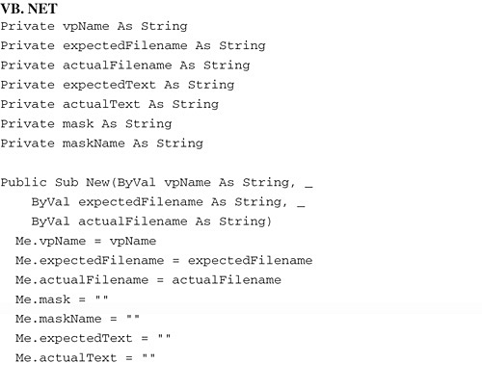

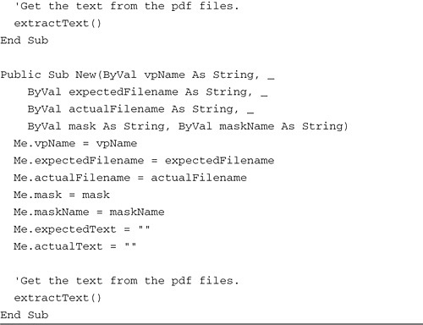

**Extracting Text from the PDF Files**

The PdfTextVerificationPoint class needs to extract the text from the expected and actual PDF files. You can write this code easily by using classes from the PDFBox libraries. The PDDocument class represents the PDF file, and the PDFTextStripper knows how to extract the text from the PDF files. After you extract the text, you then replace all instances of text that match the mask with the mask name (if a mask is required). Both Java and .NET provide methods for working with strings and regular expressions to accomplish this task. Refer to [Listing 12.4](https://www.safaribooksonline.com/library/view/software-test-engineering/9780137036455/ch12.html#ch12ex04).

**Listing 12.4** Extracting text

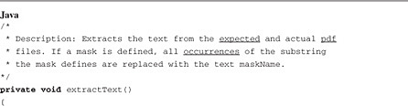

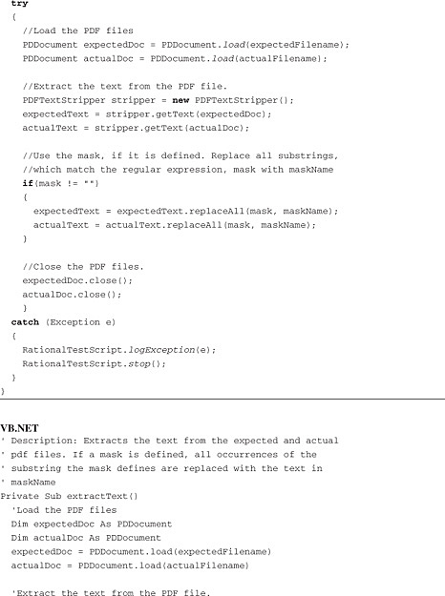

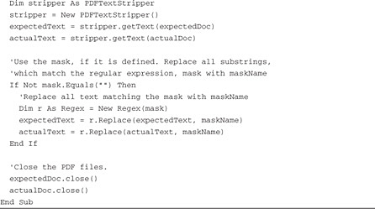

**Performing the Test**

The PdfTextVerification point now has everything it needs to test the text of the expected and actual PDF files. Comparing large amounts of text with any kind of sophistication is not a trivial task. Fortunately, the google-diff-match-patch library can do the work for you. With only a couple of lines of code, you can retrieve a list that represents the differences between the two blocks of text. Further, the google-diff-match-patch library can output the results in a “pretty” HTML format, which graphically displays the differences. You can take advantage of these capabilities to write a simple, yet effective performTest method as shown in [Listing 12.5](https://www.safaribooksonline.com/library/view/software-test-engineering/9780137036455/ch12.html#ch12ex05).

**Listing 12.5** performTest

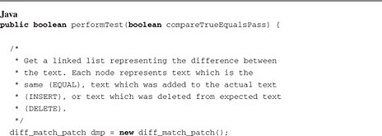

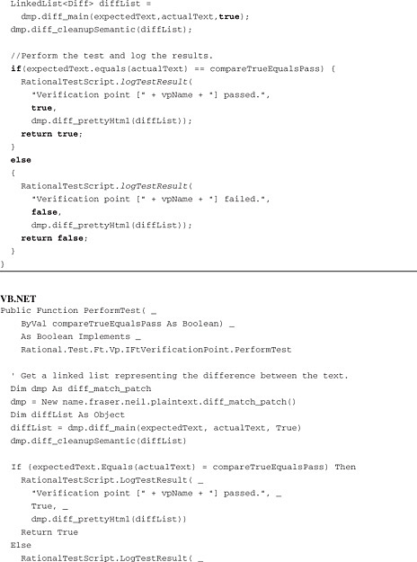

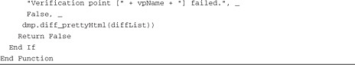

**Taking into Account Variable PDF Generation Times**

It is possible that the application under test takes a variable amount of time to generate a PDF file. The IftVerificationPoint interface contains instances of the performTest and compare methods, which take this into account. The caller provides the maximum test time (in seconds) and the delay between retries (also in seconds). These methods then repeat the test at the interval defined by the delay until either time runs out or the verification point passes. [Listing 12.6](https://www.safaribooksonline.com/library/view/software-test-engineering/9780137036455/ch12.html#ch12ex06) shows one possible way to implement this capability.

**Listing 12.6** Compare and performTest with retry

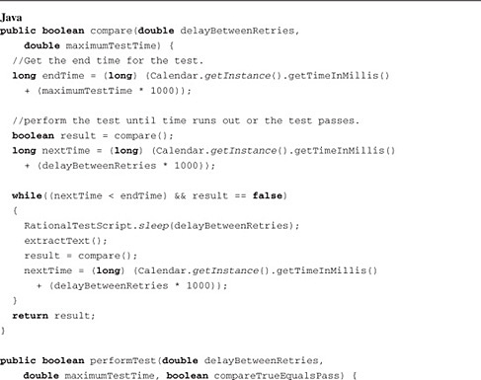

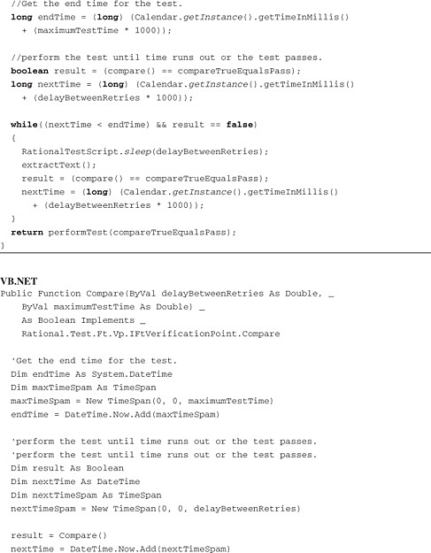

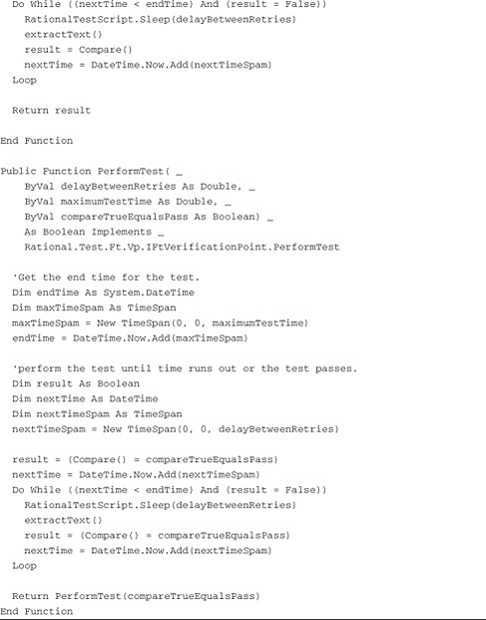

**Completing the Remaining Methods**

The remaining methods of the IftVerificationPoint interface, shown in [Listing 12.7](https://www.safaribooksonline.com/library/view/software-test-engineering/9780137036455/ch12.html#ch12ex07), are trivial. There are some get methods, some additional instances of the performTest method, and some compare methods.

**Listing 12.7** Trivial methods

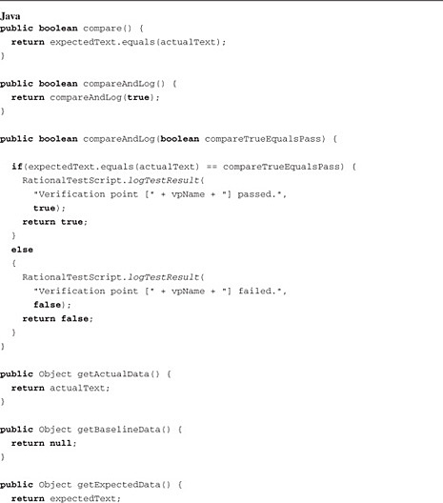

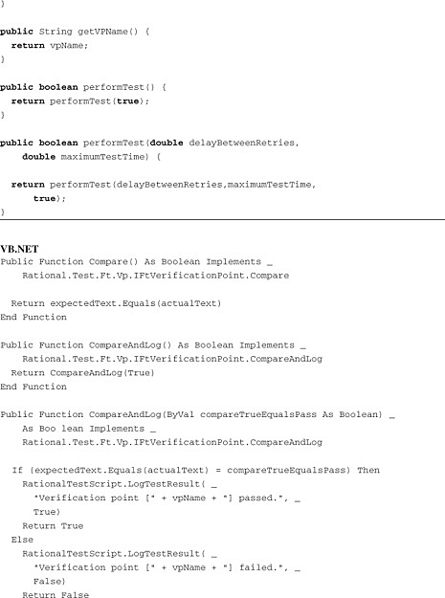

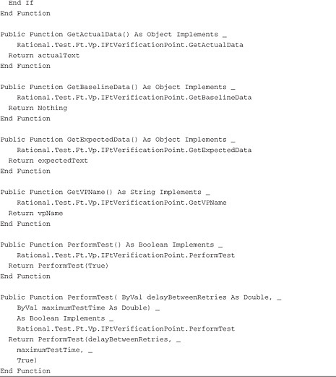

**Helper Super Class**

This solution has a helper super class called PDFBoxHelperSuperClass, which contains a predefined mask for a date field, and some helper functions for returning a PDF text verification point. This class, shown in [Listing 12.8](https://www.safaribooksonline.com/library/view/software-test-engineering/9780137036455/ch12.html#ch12ex08), makes using the new PDF text verification point easy.

**Listing 12.8** PdfBoxHelperSuperClass

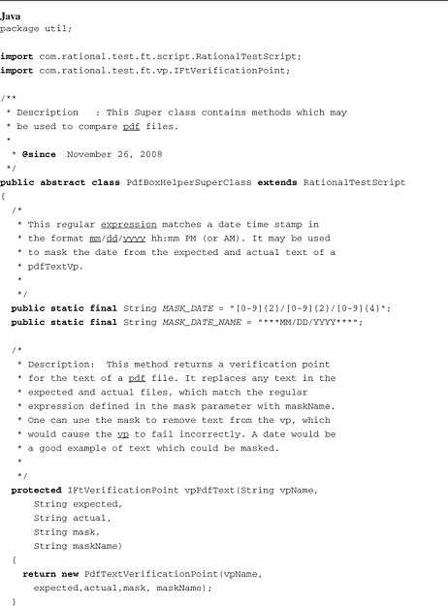

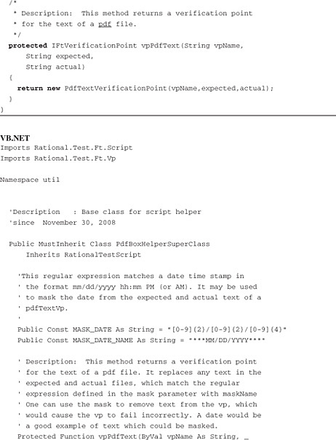

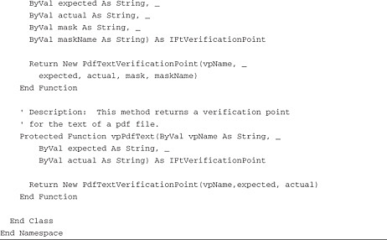

**Writing to a Custom Log File with Log4j and Log4net**

Log4j and Log4net are open source utilities for writing log files from a Java program or a .NET program. They provide an easy-to-use powerful set of classes. You log data using hierarchical categories and levels, and you can control the behavior of your logging in powerful ways from a configuration file. This way, you can change how you log without changing your test scripts. You can, for example, turn on trace logs only for one test script in a suite. You can control the level of information, the output destination (the console, a file, a socket, and so on), and the layout of the log. All of this behavior can be specified by categories that you define.

This section describes how to use Log4J and Log4net in the context of Rational Functional Tester. We start with a simple Rational Functional Tester test script that writes logs to the console by calling log methods. The Java version of the script is called log4jExample1 and the VB.NET version of the script is called log4netExample1. Both are located in the testScripts folder. If you run the .NET version of this script, execute the script by selecting Debug Functional Test Script instead of Run Functional Test Script (the bug icon instead of the green triangle). Otherwise, you do not see anything in the output view. When you run the script, you get the following output:



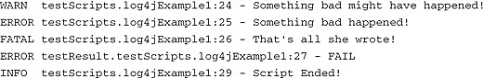

You now explore manipulating the logging output of the test script by changing the configuration file. We change the log level (although the messages logged from this script are the same), the format of the log messages, and the destination of the log messages. When you run the Example1 test script using the new configuration file, the script writes logs to the console and to the files logs\log.txt and logs\results.txt. The following is output to both the console and to the log.txt:

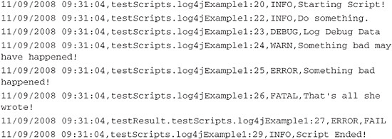

The following is output to the file logs\results.txt:

09/02/2008 01:05:16,testResult.testScripts.log4jExample1,FAIL

Finally, you create your own custom logging solution that automatically writes the result of running a test script (pass, fail, or warning) to a summary log (logs\results.txt) and that writes detailed logs to the file logs\log.txt. The only change you have to make to the test script is to set its helper super class to be util.LogHelperSuperClass. No changes need to be made to the code in the script.

A test script is provided; it uses the logging solution. The Java version of the script is called log4jExample2, and the .NET version is called log4netExample2. Again, both are located in the testScripts folder. This script, shown in [Listing 12.9](https://www.safaribooksonline.com/library/view/software-test-engineering/9780137036455/ch12.html#ch12ex09), tests the ClassicsJavaA application. It selects and purchases a CD. Along the way, it verifies that the purchase price is correct and also that the confirmation message is correct. Because the confirmation message has a one up number in it, this verification point fails.

**Listing 12.9** Log example test script

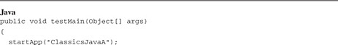

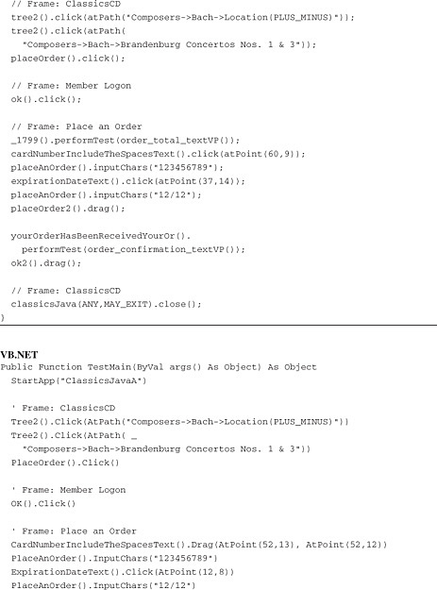

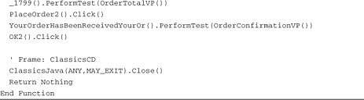

When you execute the test script, and pass in build1 as a run argument, the following is output to the console and appended to the file logs\log.txt:

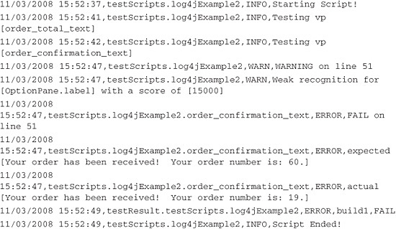

You also get the following appended to the logs\results.txt file:

11/03/2008  
15:52:49,testResult.testScripts.log4jExample2,build1,FAIL

**Setting Up the Logging Example for RFT Java Projects**

Follow the instructions in this section to set up the logging example. You can download the example code from [www.ibm.com/developerworks/rational/library/09/testengineeringrft/index.html](http://www.ibm.com/developerworks/rational/library/09/testengineeringrft/index.html). Unzip the file Chapter12.zip into a directory of your choosing. The setup steps assume you unzipped into the directory C:\.

**Importing the Example into an Existing RFT Java Project**

Follow these instructions to import the example into an existing RFT Java project:

**1.** Create a new RFT Java project (or use an existing one).

**2.** From RFT, select **Import** from the File menu.

**3.** In the Import dialog box, expand the Other folder and select **Functional Test Project Items** (see [Figure 12.8](https://www.safaribooksonline.com/library/view/software-test-engineering/9780137036455/ch12.html#ch12fig08)).

**Figure 12.8** Import RFT Java project items

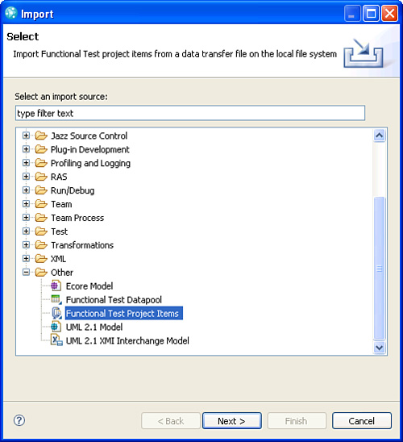

**4.** Select **Next**.

**5.** Next to **Transfer File**, select the file **log4j.rftjdtr** from the directory \Ch12 Downloads\RFT Java.

**6.** Under **Select the import location**, select the destination RFT Java project (see [Figure 12.9](https://www.safaribooksonline.com/library/view/software-test-engineering/9780137036455/ch12.html#ch12fig09)).

**Figure 12.9** Import log4j.rftjdtr

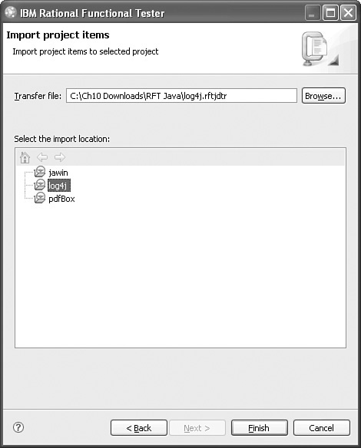

**7.** Select **Finish**.

**Configuring the RFT Java Project to Use log4j**

To set up log4j in a new RFT Java project you add a reference to the JAR file log4j-1.2.15.jar. You can either download it from the Apache Software Foundation (<http://logging.apache.org/>) or you can use the JAR file contained in the transfer file you just imported. The instructions that follow assume you are using the JAR file we provided.

**1.** Right-click your RFT Java project and select **Properties.**

**2.** In the **Properties** dialog box, select **Java Build Path**, and then select the **Libraries** tab (see [Figure 12.10](https://www.safaribooksonline.com/library/view/software-test-engineering/9780137036455/ch12.html#ch12fig10)).

**Figure 12.10** The Java build path

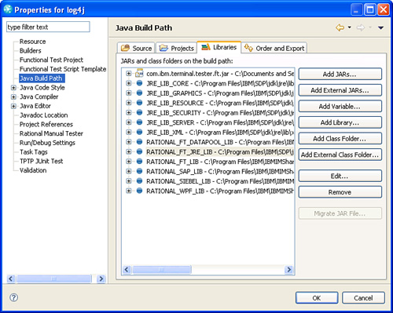

**3.** Select the **Add External JARs** button.

**4.** Navigate to the **jars** directory now in your RFT Java project. Select the JAR file **log4j-1.2.15.jar**.

**5.** Select **OK.**

**Setting Up the Logging Example for RFT .NET**

Follow the instructions in this section to set up the logging example. You can download the example code from [www.ibm.com/developerworks/rational/library/09/testengineeringrft/index.html](http://www.ibm.com/developerworks/rational/library/09/testengineeringrft/index.html). Unzip the file Chapter12.zip into a directory of your choosing. The setup steps assume you unzipped into the directory C:\.

**Importing the Example into an Existing RFT .NET Project**

Follow these instructions to import the example into an existing RFT .NET project:

**1.** Create a new RFT .NET project (or use an existing one).

**2.** In the Solution Explorer view, right-click on your project and select **Import**.

**3.** In the Select Data Transfer File dialog box, select the file **log4net.rftvdtr**. It is in the directory C:\Ch12 Downloads\RFT .NET\.

**4.** Select **Finish**.

**5.** Copy the folders config and logs into the RFT .NET Project directory. These folders are located in the file C:\Ch12 Downloads\RFT .NET\log4net.zip. Your project should appear as follows as shown in [Figure 12.11](https://www.safaribooksonline.com/library/view/software-test-engineering/9780137036455/ch12.html#ch12fig11).

**Figure 12.11** RFT .NET project after importing log4net example

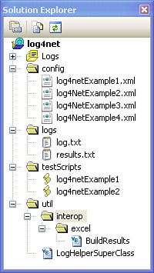

**6.** Open the file **log4NetExample3.xml** (located in the config folder).

**7.** Change line <file value="c:\temp\logs\log.txt"/> to point to the log.txt file now in your RFT .NET project. For example, it might read <file value="C:\Documents and Settings\YOU\My Documents\Visual Studio 2005 \ Projects\log4net\log4net\logs\log.txt"/>.

**8.** Change line <file value="c:\temp\logs\results.txt"/> to point to the results.txt file now in your RFT .NET project. For example, it might read <file value="C:\Documents and Settings\YOU\My Documents\Visual Studio 2005\Projects\log4net\log4net\logs\results.txt"/>.

**9.** Repeat steps 6–8 for the file **log4NetExample4.xml**.

**Configuring the RFT .NET Project to Use Log4net**

To set up log4net in a new RFT .NET project, you add a reference to the assembly log4net.dll. You can either download it from the Apache Software Foundation (<http://logging.apache.org/>) or you can use the assembly provided in the file C:\Ch12 Downloads\RFT.NET\assembiles.zip.

**1.** Copy the assembly file **log4net.dll** into the RFT .NET customization directory. By default, this directory is located at C:\Documents and Settings\All Users\Application Data\IBM\RFT\customization.

**2.** Restart Rational Functional Tester.

**Understanding the Simple Example**

This section starts by explaining the simple example.

**Reading the Configuration File**

The examples use configuration files to control logging behavior. This way, you can alter your logging without changing any script code. [Listing 12.10](https://www.safaribooksonline.com/library/view/software-test-engineering/9780137036455/ch12.html#ch12ex10) shows how to read an XML configuration file, which is located in the config folder of the RFT .NET project:

**Listing 12.10** Reading the configuration file

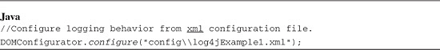

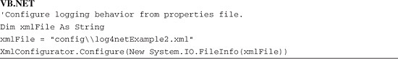

**Setting Up Loggers**

You write messages to your log using a class called Logger. When you create a Logger object, you give that logger a name. A good best practice is to use the name of the test script as the name of any logger in that test script. You create two loggers. One logger is for logging what happens in the test script. This one has the name of the test script. The other logger is for logging the overall results of the test script. In [Listing 12.11](https://www.safaribooksonline.com/library/view/software-test-engineering/9780137036455/ch12.html#ch12ex11), this logger is given the name testResult.scriptName so that all of the test script results in the log can be easily found.

**Listing 12.11** Setting up Loggers

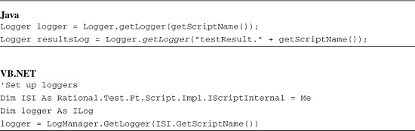

**Logging Some Messages**

Finally, let’s log some messages. You can log six levels of messages: trace, debug, info, warning, error, and fatal. In [Listing 12.12](https://www.safaribooksonline.com/library/view/software-test-engineering/9780137036455/ch12.html#ch12ex12), you log the start and ending of the script, and some information messages, warning messages, and error messages.

**Listing 12.12** Logging some messages

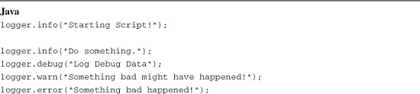

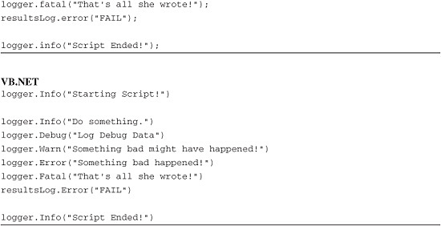

**The Configuration File**

XML is used in [Listing 12.13](https://www.safaribooksonline.com/library/view/software-test-engineering/9780137036455/ch12.html#ch12ex13) for this example. Logs are sent to the console using the defined layout. You look at the configuration file more in the next section.

**Listing 12.13** The configuration file

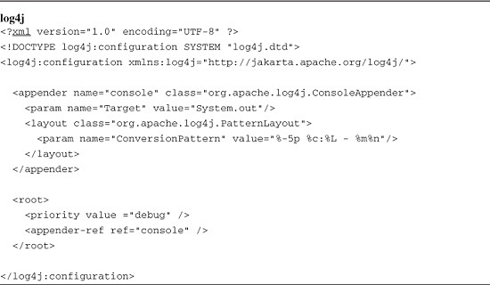

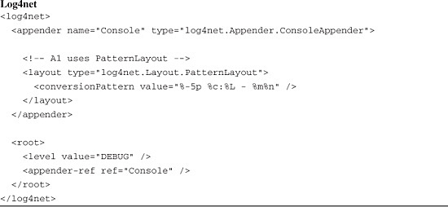

**Changing Log Behavior via the Configuration File**

Log4j and log4net enable you to configure the logging behavior in powerful ways. You can configure which logs get written and which get ignored based upon log level. You can configure where a log message goes. Finally, you can configure the layout of the messages in the logs. This section provides a brief description for how to configure log4j and log4net within the context of Rational Functional Tester. For a detailed description of the configuration options, refer to the documentation.

**Configuring the Log Level**

You control which messages are logged and which are ignored by setting the log level. The level can be set to TRACE, DEBUG, INFO, WARN, ERROR, or FATAL. Only messages that have a level equal to or greater than the set level get output. The lowest level is TRACE and the highest is FATAL. If, for example, we set the log level to INFO, all trace and debug messages are ignored. One useful way to filter logs in Rational Functional Tester is to turn on debug logging for a single test script, whereas other test scripts ignore debug logs. In [Listing 12.14](https://www.safaribooksonline.com/library/view/software-test-engineering/9780137036455/ch12.html#ch12ex14), you change the configuration file so that the level of the root logger is set to INFO. This means all TRACE and DEBUG log messages are ignored. However, we also set the log level of the testScripts.log4jExample1 Logger to DEBUG. Because you use the test script name as the name of the logger, the log4jExample1 test script in the testScripts folder outputs DEBUG log messages.

**Listing 12.14** Configuring the log level

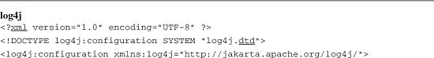

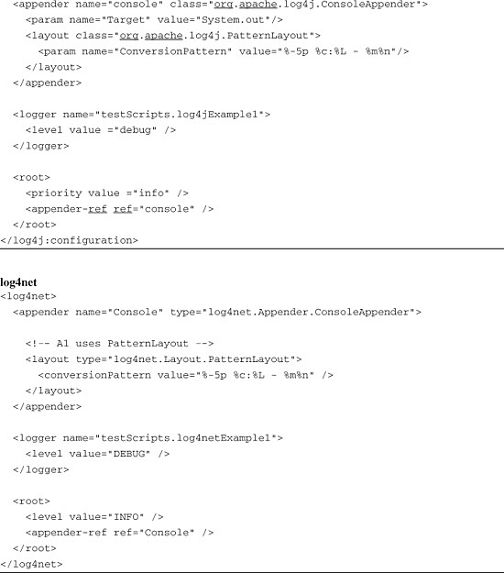

**Configuring the Output Destination**

You can control the destination of log messages by configuring appenders. There are many options to choose from including the console, files, and remote socket servers. You can send messages to one or multiple destinations. In the logging example, you want to parse out the overall verdict of each test script from the log file. You can simply change the logging configuration to send all test result verdicts to a separate file. In the configuration file shown in [Listing 12.15](https://www.safaribooksonline.com/library/view/software-test-engineering/9780137036455/ch12.html#ch12ex15), you extend the example to contain three appenders. The console appender sends log messages to the console, the LogFile appender sends logs messages to the file log.txt, and the ResultsFile appender sends messages to the file results.txt. Further, you define that all loggers whose name starts with testResult send messages to the result.txt file.

**Listing 12.15** Configuring the output destination

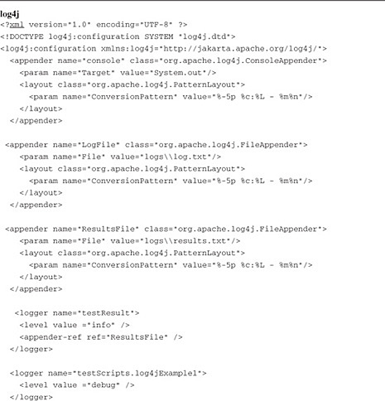

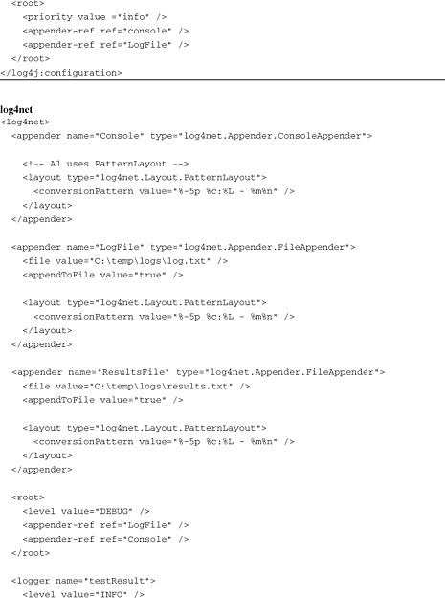



**Configuring the Format**

You can control the format of log messages for each appender using pattern layouts. The pattern used so far is %-5p %c:%L - %m%n. When a message is sent to an appender, each conversion specifier (% followed by format modifiers and a conversion character) is replaced with information about the message. In this case, p is the log priority (INFO, WARN, ERROR, and so on), c is the category, L is the line number, m is the message, and n is a new line. In the Rational Functional Tester logging example, you output all log messages delimited by commas. This makes it easy to parse the logs using applications such as Microsoft Excel. You also add the date and time to the logs. The pattern is %d{MM/dd/yyyy HH:mm:ss},%c:%L,%p,%m%n. Refer to the log4j and log4net documentation for a complete list of all format modifiers and conversion characters. [Listing 12.16](https://www.safaribooksonline.com/library/view/software-test-engineering/9780137036455/ch12.html#ch12ex16) shows the completed configuration file with the updated layouts:

**Listing 12.16** Configuring the format

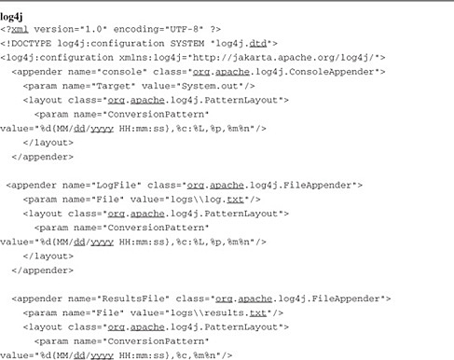

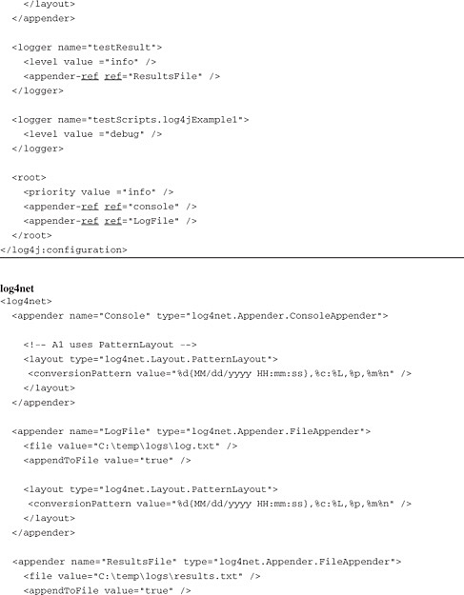

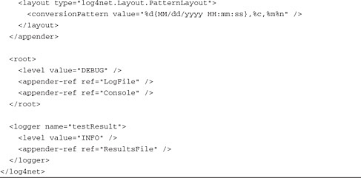

**Understanding the LogHelperSuperClass**

In this section, you generalize the solution so the start of a test script, the end of a test script, verification points, and the test script result are logged automatically as the script runs. You do this by creating a helper super class called LogHelperSuperClass and by taking advantage of the many callback methods available for Rational Functional Tester test scripts. A *callback method* is a method that Rational Functional Tester calls when a specific event happens. You can override a callback method to extend the behavior of RFT. This capability is used to write logging code that gets called when a script initializes, when a verification point starts, when a verification point fails, and when a script terminates. The Java and .NET implementations are essentially the same. There are some minor differences in the names of the log4j and log4net classes and the format of the logging configuration file, but the concepts and approaches are identical. Refer to [Figure 12.12](https://www.safaribooksonline.com/library/view/software-test-engineering/9780137036455/ch12.html#ch12fig12) for a Unified Modeling Language (UML) representation of the Java logging solution, and refer to [Figure 12.13](https://www.safaribooksonline.com/library/view/software-test-engineering/9780137036455/ch12.html#ch12fig13) for a UML representation of the .NET solution.

**Figure 12.12** Class diagram of log4jExample

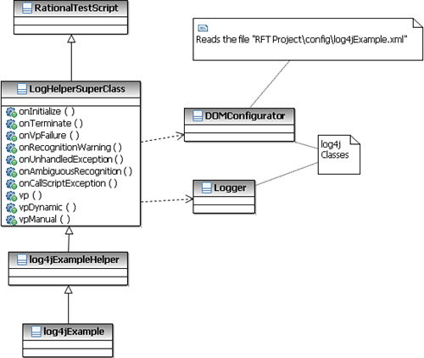

**Figure 12.13** Class diagram of log4netExample

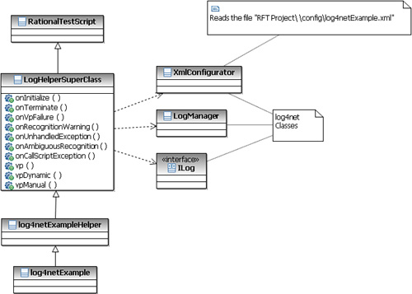

**Script Initialization**

Rational Functional Tester calls a method called onInitialization before it runs testMain. Here is where you initialize the logging framework and read the configuration file. It is possible that many test scripts might be called in a single run (using callScript), and you need to make sure the properties file is read only once. Similar to the simple example, you log the fact that the test script has started. Finally, you set the build of the test run by assigning the first argument passed into the script to be the build. If no arguments are passed, the build is set to unspecified. See [Listing 12.17](https://www.safaribooksonline.com/library/view/software-test-engineering/9780137036455/ch12.html#ch12ex17).

**Listing 12.17** Script initialization

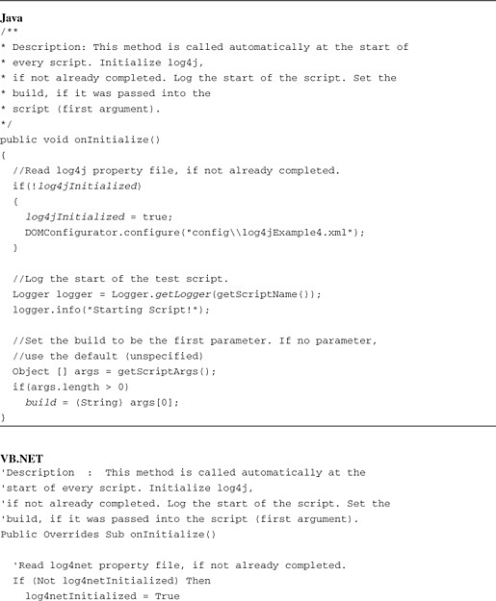

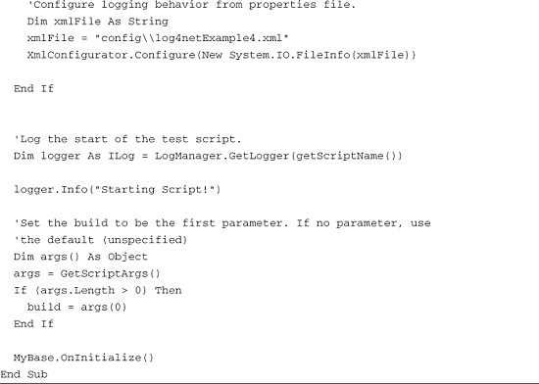

**Script Termination**

You can complete similar actions when a script completes by overriding the onTerminate method. This method is called whenever a script completes. In [Listing 12.18](https://www.safaribooksonline.com/library/view/software-test-engineering/9780137036455/ch12.html#ch12ex18), you log the results (which you calculate as the script runs), and you log the fact that the script ended.

**Listing 12.18** Script termination

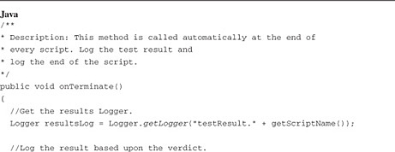

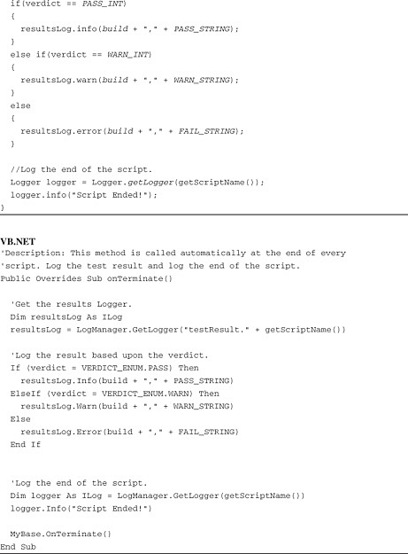

**Logging Failures**

Now you need a way to log verification point results and to calculate the overall result of running a test script. For the overall result, you use a simple approach. If all verification points pass, the overall verdict is PASS. If the test script recognizes an object, but the recognition score is greater than the threshold, the verdict is WARN. If any verification point in the test script fails, the overall verdict is FAIL.

Rational Functional Tester provides a callback method called onVpFailure, which is called any time a verification point fails. In [Listing 12.19](https://www.safaribooksonline.com/library/view/software-test-engineering/9780137036455/ch12.html#ch12ex19), you override this method in order to log a message about the failure and to indicate the test script has an overall verdict of fail.

**Listing 12.19** onVpFailure

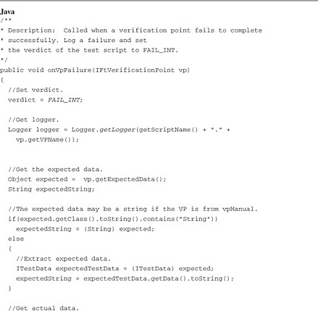

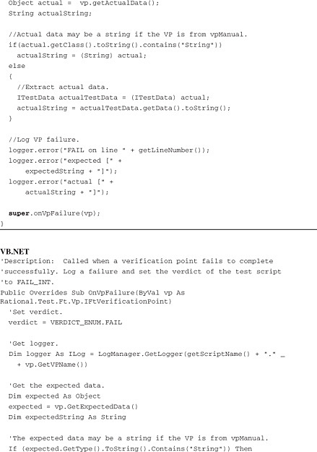

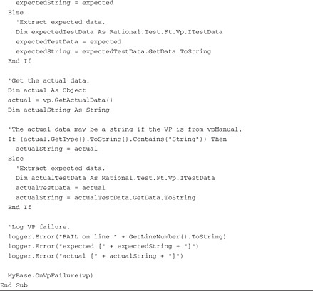

**Logging Warnings**

Whenever a test script finds an object, but the object’s recognition score exceeds the warning threshold, Rational Functional Tester calls the onRecognitionWarning method. In [Listing 12.20](https://www.safaribooksonline.com/library/view/software-test-engineering/9780137036455/ch12.html#ch12ex20), you override this method to set the verdict to WARNING. Note that if the verdict is already FAIL, you leave it as is.

**Listing 12.20** onRecognitionWarning

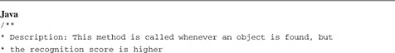

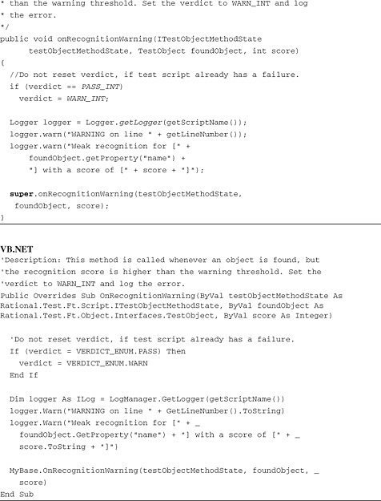

**Handling Additional Callbacks**

There are many other callback methods that are called when a Rational Functional Tester test script throws an exception. In [Listing 12.21](https://www.safaribooksonline.com/library/view/software-test-engineering/9780137036455/ch12.html#ch12ex21), you override these methods to set the verdict to FAIL and to log the event.

**Listing 12.21** Additional callbacks

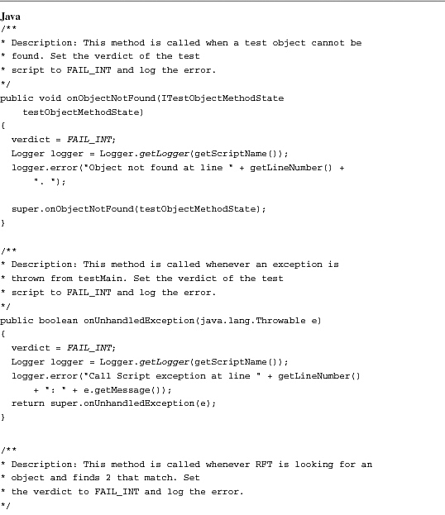

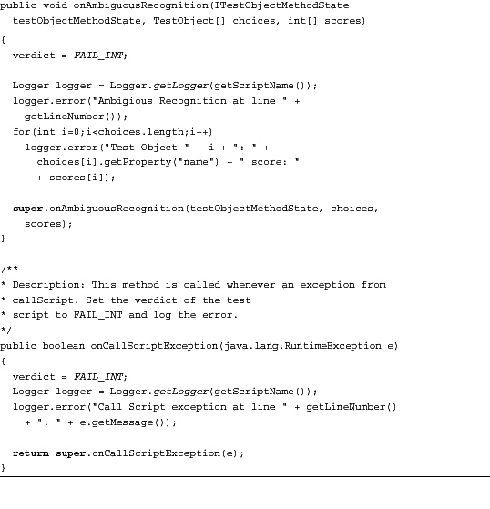

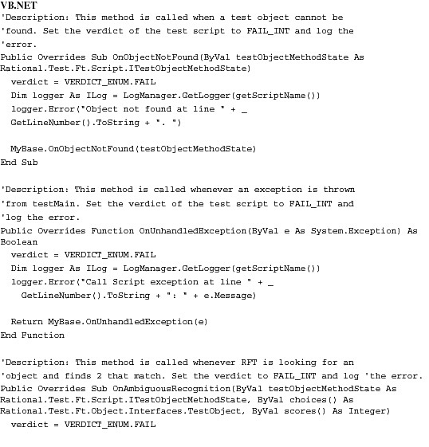

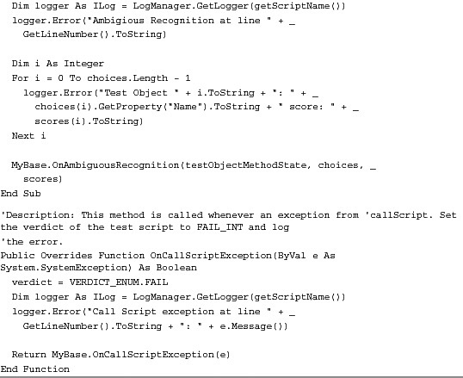

**Logging a Pass**

No callback methods execute when a verification point passes. You can add code after each verification point to check the results and log PASS, but this is too intrusive. Instead, you override the vp method and log a message to indicate that the verification point is about to be executed. This method, shown in [Listing 12.22](https://www.safaribooksonline.com/library/view/software-test-engineering/9780137036455/ch12.html#ch12ex22), is called whenever a test script prepares to execute a verification point. You then pass control back to the API so that processing continues as before. With this approach, if the log says a verification point executed and there are not failure logs, the verification point has passed.

**Listing 12.22** Logging a pass

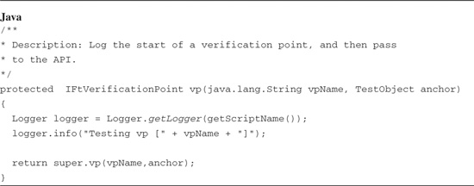

You also need to handle manual and dynamic veri.cation points. You do so in a similar way:

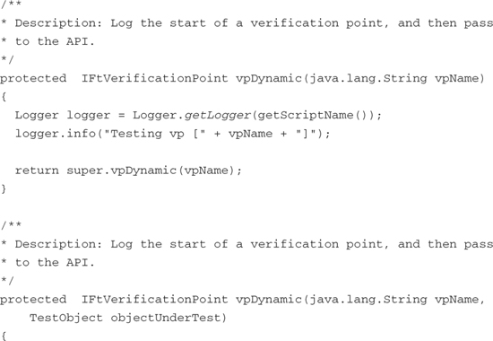

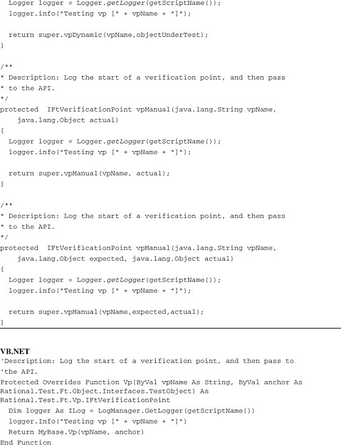

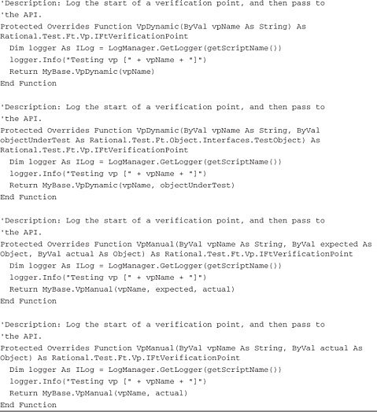

**Interfacing with COM Scriptable Components**

It is sometimes useful to call a COM scriptable component from RFT. The application under test might be a COM-based application and you want to write a custom test harness, or you might want to write a utility that uses a COM component. In this section, you learn how to interface to a commonly used COM scriptable component, Microsoft Excel. You use Jawin to interface to Excel from RFT Java, and .NET Com Interop classes to interface to Excel from RFT .NET. Jawin is an open source library that stands for the Java/Win32 integration project. It enables you to easily make calls to COM components and Win32 .dlls from a Java program. You can use JNI for the same purpose, but Jawin requires much less work and produces cleaner code. The .NET COM Interop classes are .NET libraries, which encapsulate the interface to applications such as Excel. They enable you to manipulate Excel from your Rational Functional Tester scripts using a reference to the Excel Object Model.

You start by developing a simple script that creates an Excel workbook with the text Hello World in the first cell. When you run this script, it creates an Excel workbook as pictured in [Figure 12.14](https://www.safaribooksonline.com/library/view/software-test-engineering/9780137036455/ch12.html#ch12fig14).

**Figure 12.14** A simple Excel workbook created from a Rational Functional Tester script

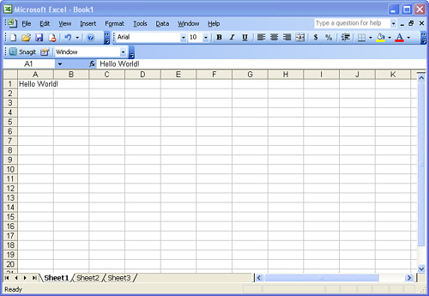

Next, you explore an example of a utility Rational Functional Tester script, which creates a Chart in Excel from the results.txt file. This file is an output from the logging solution described in the section “[Writing to a Custom Log File with Log4j and Log4net](https://www.safaribooksonline.com/library/view/software-test-engineering/9780137036455/ch12.html#ch12sec1lev2).” The chart can be generated automatically after running a large set of Rational Functional Tester scripts. The Java version of the test script is called jawinExample2, and the .NET version is called MSInteropExample2. Both are located in the testScripts folder. When you execute this test, it creates a new Excel workbook similar to the one shown in [Figure 12.15](https://www.safaribooksonline.com/library/view/software-test-engineering/9780137036455/ch12.html#ch12fig15).

**Figure 12.15** Result data and chart in Excel

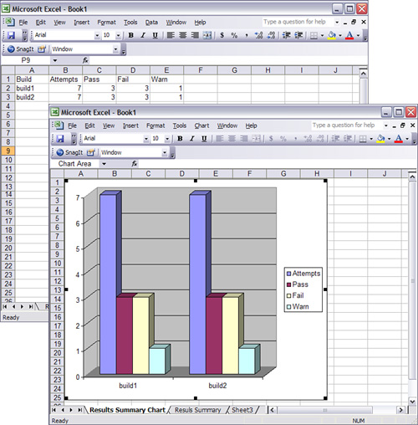

**Setting Up the Charting Example for RFT Java**

Follow the instructions in this section to set up the charting example. You can download the example code from [www.ibm.com/developerworks/rational/library/09/testengineeringrft/index.html](http://www.ibm.com/developerworks/rational/library/09/testengineeringrft/index.html). Unzip the file Chapter12.zip into a directory of your choosing. The setup steps assume you unzipped into the directory C:\.

**Importing the Example into an Existing RFT Java Project**

Follow these instructions to import the example into an existing RFT Java project:

**1.** Create a new RFT Java project (or use an existing one).

**2.** From RFT, select **Import** from the File menu.

**3.** In the Import dialog box, expand the Other folder and select **Functional Test Project Items** (see [Figure 12.16](https://www.safaribooksonline.com/library/view/software-test-engineering/9780137036455/ch12.html#ch12fig16)).

**Figure 12.16** Import RFT Java project items.

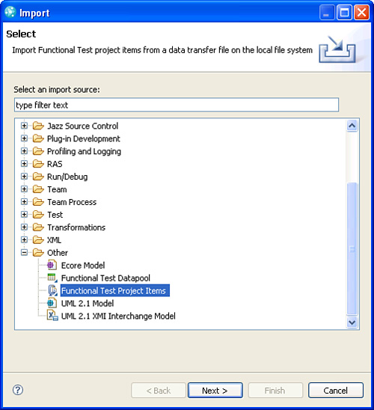

**4.** Select **Next**.

**5.** Next to Transfer File, select the file **jawin.rftjdtr** from the directory \Ch12 Downloads\RFT Java.

**6.** Under Select the import location, select the destination RFT Java project (see [Figure 12.17](https://www.safaribooksonline.com/library/view/software-test-engineering/9780137036455/ch12.html#ch12fig17)).

**Figure 12.17** Import jawin.rftjdtr

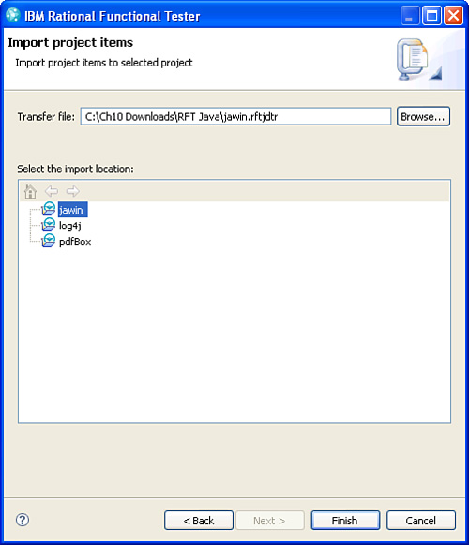

**7.** Select **Finish**.

**Configuring the RFT Java Project to Use Jawin**

To set up Jawin in a new RFT Java project, you add a reference to the JAR file jawin.jar. You also load the Jawin native code in the file jawin.dll. To do so, you need to place the jawin.dll file in a directory that is referenced from the standard java.library path property. RFT sets this property to include the directory <installation dir>\jdk\jre\bin, so simply copy the jawin.dll into that directory. You can download the latest versions of jawin.jar and jawin.dll from the Apache Logging Services Project web page (<http://logging.apache.org/>), or you can use files provided in the transfer file you just imported. The instructions that follow assume you are using the files provided.

**1.** Right-click on your RFT Java project and select **Properties.**

**2.** In the Properties dialog, select **Java Build Path**, and then select the **Libraries** tab (see [Figure 12.18](https://www.safaribooksonline.com/library/view/software-test-engineering/9780137036455/ch12.html#ch12fig18)).

**Figure 12.18** The Java Build Path

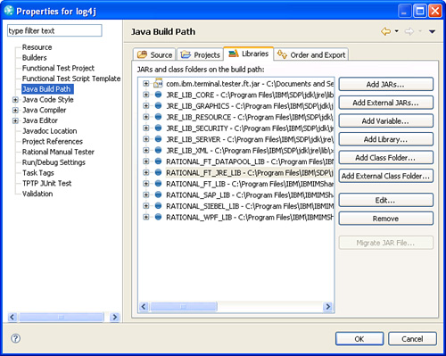

**3.** Select the **Add External Jars** button.

**4.** Navigate to the jars directory in your RFT Java project. Select the JAR file **jawin.jar**.

**5.** Select **OK.**

**6.** Copy the file jawin.dll into the directory <RFT installation dir>\jdk\jre\bin (in a standard install, this directory is C:\Program Files\IBM\SDP\jdk\jre\bin). The dll is located in the jars directory in your RFT Java project.

**7.** Restart RFT.

**Setting Up the Logging Example for RFT .NET**

Follow the instructions in this section to set up the logging example. You can download the example code from [www.ibm.com/developerworks/rational/library/09/testengineeringrft/index.html](http://www.ibm.com/developerworks/rational/library/09/testengineeringrft/index.html). Unzip the file Chapter12.zip into a directory of your choosing. The setup steps assume you unzipped into the directory C:\.

**Importing the Example into an Existing RFT .NET Project**

Follow these instructions:

**1.** Create a new RFT .NET project (or use an existing one).

**2.** In the Solution Explorer view, right-click on your project and select **Import**.

**3.** In the Select Data Transfer File dialog box, select the file **msinterop.rftvdtr**. It is in the directory C:\Ch12 Downloads\RFT .NET\.

**4.** Select **Finish**.

**5.** Copy the folder logs into the RFT .NET Project directory. This directory is contained in the file C:\Ch12 Downloads\RFT .NET\msinterop.zip. Your project should appear as shown in [Figure 12.19](https://www.safaribooksonline.com/library/view/software-test-engineering/9780137036455/ch12.html#ch12fig19).

**Figure 12.19** RFT .NET project after importing MsInterop example

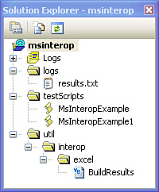

**Configuring the RFT .NET Project to Use Microsoft Office Interop**

To set up Microsoft Office Interop in a new RFT .NET project, you add a reference to the assembly Microsoft.Office.Interop.Excel.dll. You can either download it from Microsoft ([www.msdn.com](http://www.msdn.com/)), or you can use the assembly provided in the file C:\Ch12 Downloads\RFT.NET\assembiles.zip.

**1.** Copy the assembly file Microsoft.Office.Interop.Excel.dll into the RFT .NET customization directory. By default, this directory is located at C:\Documents and Settings\All Users\Application Data\IBM\RFT\customization.

**2.** Restart Rational Functional Tester.

**Understanding the Simple Example**

In this section, you learn how to develop the Hello World Excel-RFT script. Because this script makes calls to the Excel COM API, it is useful for you to familiarize yourself with that interface and to have the interface documentation available. You can find this documentation on the MSDN website ([http://msdn.microsoft.com](http://msdn.microsoft.com/)). Search for Excel Object Model. This uses Microsoft Excel 2003.

**Simple Example in VBA**

A trick to understanding how to use the Excel COM interface is to use the macro recording capability of Excel and then to examine the generated VBA code. If you record a macro from Excel to generate the VBA code for this example, your code would look something like [Listing 12.23](https://www.safaribooksonline.com/library/view/software-test-engineering/9780137036455/ch12.html#ch12ex23).

**Listing 12.23** Hello World

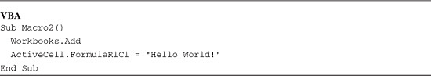

Let’s see what you need to do to convert this code to Java using Jawin and to .NET using the Microsoft Excel Primary Interop assembly.

**Simple Example in Java**

Jawin provides an interface for invoking methods in COM and Win32 .dlls. It is simple and does not require you to write any native code. To use Jawin from a Rational Functional Tester script, you must initialize the COM library. When you are done you uninitialize the library. You also need to either catch or throw the COMException. [Listing 12.24](https://www.safaribooksonline.com/library/view/software-test-engineering/9780137036455/ch12.html#ch12ex24) is a skeleton of what your Rational Functional Tester script might look like when calling Jawin code. Note that throws COMException is added to the testMain method declaration.

**Listing 12.24** Initializing COM library

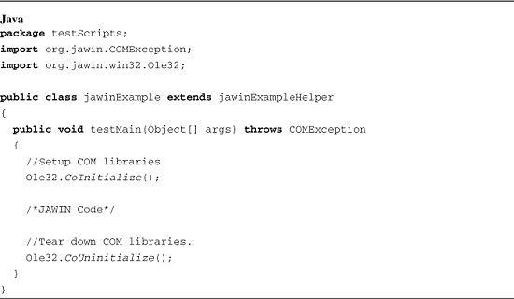

You use the DispatchPtr class from the Jawin library to interface to any scriptable COM object. You first need to get a handle for the top-level object, and then you can invoke methods, get properties, and set properties per the object’s published interface. [Listing 12.25](https://www.safaribooksonline.com/library/view/software-test-engineering/9780137036455/ch12.html#ch12ex25) is the code for accessing the top-level COM object for Excel.

**Listing 12.25** Getting the top-level DispatchPtr

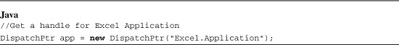

Now that you have access to Excel, you can open a new workbook. In the recorded example, you see that you can add a new workbook by calling Workbooks.Add. A review of the Excel Object Model shows that the Application object has a Workbooks property that represents all open workbooks. You can therefore add a new workbook by getting a handle for the Workbooks property and calling its Add method. In this example, you can access the Workbooks property by calling the get method of the DispatchPtr class that represents the Excel Application object. This call returns another instance of the DispatchPtr class. You can call the Add method of the Workbooks property by calling invoke from the DispatchPtr class that represents the Workbook property. The Java code in [Listing 12.26](https://www.safaribooksonline.com/library/view/software-test-engineering/9780137036455/ch12.html#ch12ex26) completes these actions. Note that the code also sets the Visible property to true. This causes Excel to display the workbook so you can see the automation as it happens.

**Listing 12.26** Creating a new workbook

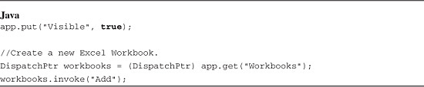

To complete the example, you need to set the FormulaR1C1 property of the ActiveCell object. Similar to the previous example, you can accomplish this by getting a handle on the ActiveCell object, and then setting its FormulaR1C1 property. [Listing 12.27](https://www.safaribooksonline.com/library/view/software-test-engineering/9780137036455/ch12.html#ch12ex27) is the Java code that completes this step.

**Listing 12.27** Writing Hello World in a cell

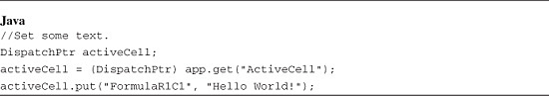

**The Simple Example in .NET**

Writing this example in a RFT .NET script is straightforward. You first create an instance of the Application class. This gives you access to both the Workbooks and ActiveCell properties. You can create a new workbook by calling the Add method of the Workbooks property, and you can set the value of the first cell by setting the Value property of ActiveCell. [Listing 12.28](https://www.safaribooksonline.com/library/view/software-test-engineering/9780137036455/ch12.html#ch12ex28) shows the RFT .NET example script:

**Listing 12.28** The Hello World Rational Functional Tester script

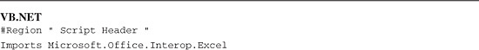

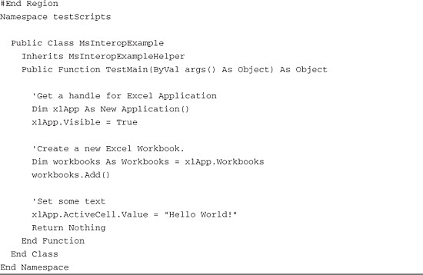

**Understanding the Results Chart Example**

Now that you understand the basics, let’s move on. This section takes you through how to write a script that takes the contents of the results.txt file and places them an Excel workbook, creating a three-dimensional chart in the process.

For the Java implementation, you start by calling Jawin directly. Later, you move those calls into a set of classes that encapsulates the interface to Excel. Jawin provides a mechanism to generate a set of classes from a COM component for this purpose. You also created a class called BuildResults to represent a count of verdicts (pass, fail, warning) for each build and managed these results in the Java LinkedHashMap class. [Figure 12.20](https://www.safaribooksonline.com/library/view/software-test-engineering/9780137036455/ch12.html#ch12fig20) shows the example test script along with the generated classes, utility classes, Java classes, and Jawin classes.

**Figure 12.20** Class diagram of jawinExample

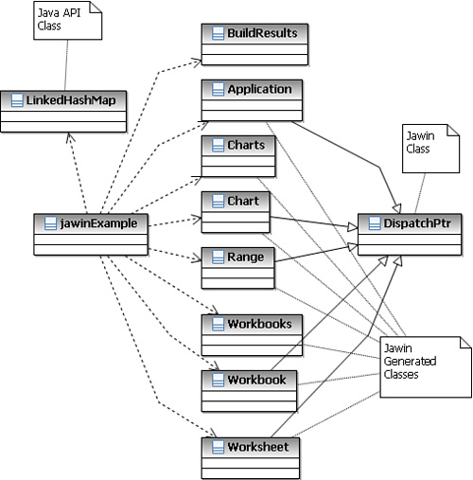

The .NET version of this example looks similar to the Java example, except you did not have to write the classes that encapsulate the interface to Excel. Like the Java example, you create a class called BuildResults to represent a count of verdicts and manage these results in the Hashtable class. [Figure 12.21](https://www.safaribooksonline.com/library/view/software-test-engineering/9780137036455/ch12.html#ch12fig21) shows the example test script along with the Excel COM Interop classes, utility classes, and .NET API classes.

**Figure 12.21** Class diagram of MsInteropExample

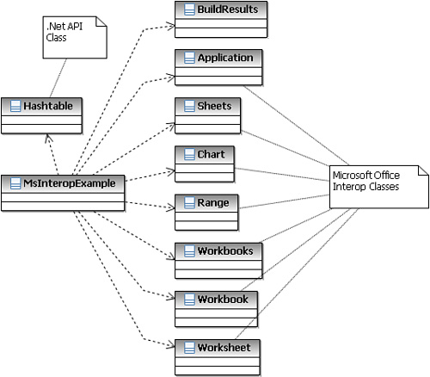

**Imports**

The first thing you need to do is to set up your imports as in [Listing 12.29](https://www.safaribooksonline.com/library/view/software-test-engineering/9780137036455/ch12.html#ch12ex29).

**Listing 12.29** Imports

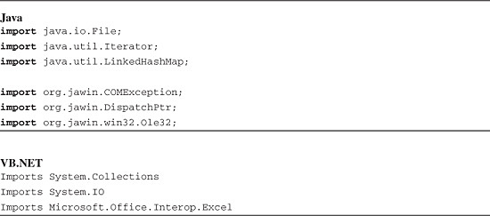

**Initialize and Break Down the COM Library (Java Only)**

Recall from the Simple Example in Java that you need to initialize and break down the COM library. You also need to catch or throw the COMException. This step, shown in [Listing 12.30](https://www.safaribooksonline.com/library/view/software-test-engineering/9780137036455/ch12.html#ch12ex30), is not required for .NET.

**Listing 12.30** Initialize and break down COM library

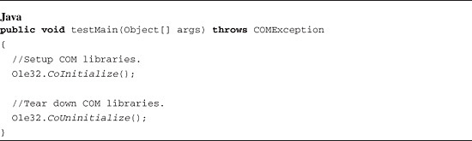

**Accessing the Excel Application**

To access Excel’s methods, properties, and child objects, you need to access the top-level COM object, the Excel application. It is nice to see Excel as your script manipulates it, and you can do so by setting the Visible property to true. Refer to [Listing 12.31](https://www.safaribooksonline.com/library/view/software-test-engineering/9780137036455/ch12.html#ch12ex31).

**Listing 12.31** Accessing the Excel application

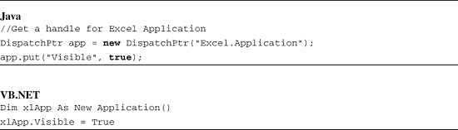

**Accessing the Workbooks Collection**

You need to gain access to the Excel workbooks collection. This enables you to create a new workbook to store the contents of results.txt. This is accomplished using the Workbooks property on your top-level object. You can then call the Add() function on the workbooks collection you just acquired, as shown in [Listing 12.32](https://www.safaribooksonline.com/library/view/software-test-engineering/9780137036455/ch12.html#ch12ex32).

**Listing 12.32** Accessing the workbooks collection

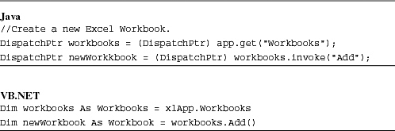

**Parsing Results.txt**

The new workbook that you created is used to store the contents of your text file. It also serves to generate a three-dimensional chart. The next step you need to perform in this example is acquiring the data from results.txt. Because this is a comma-separated file, you can take advantage of the OpenText method exposed by the workbooks collection. This method, shown in [Listing 12.33](https://www.safaribooksonline.com/library/view/software-test-engineering/9780137036455/ch12.html#ch12ex33), opens results.txt as a new workbook, parsing each comma-separated value into its own cell. You need to gain control of the worksheet that contains the actual data. This is done using the Worksheets collection of the Excel application. You need to pass the name of the worksheet you want to this collection. This is the name of the file you opened, minus the file extension. [Figure 12.22](https://www.safaribooksonline.com/library/view/software-test-engineering/9780137036455/ch12.html#ch12fig22) shows the current state of the Excel objects after completing this step.

**Figure 12.22** Opening results.txt in an Excel workbook

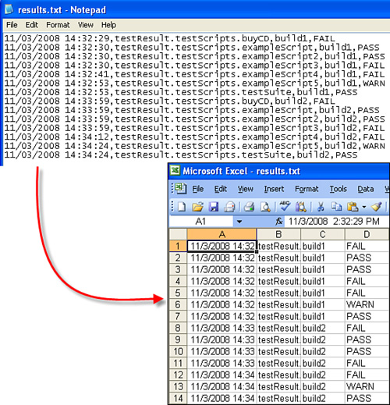

**Listing 12.33** Parsing results.txt

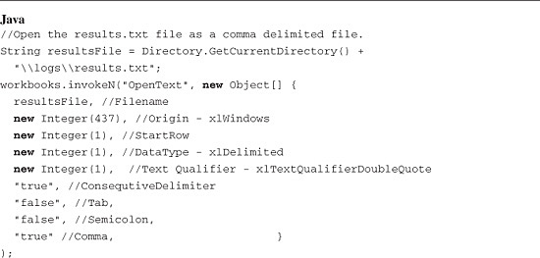

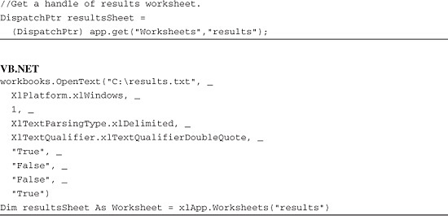

Note several things regarding invoking the OpenText method in Java. You can skip this paragraph if you care only about VB.NET. Many of the parameters are of type Variant. You have to read the text in the API to determine what type to use in your code. Further, some of the parameters are enumerations. You can use Integer to represent an enumeration, and the API tells you what number represents each value. Finally, most of the parameters are optional and may be ignored.

**Formatting the Data**

After you have control over the results data worksheet, you can now format how you want the data displayed. Returning back to the original workbook you created, newWorkbook, you will want to rename the first worksheet, sheet1, to something more intuitive such as Results Summary. You also want to create column headers to represent the build names, execution attempts per build, and results per execution. These can be created in the initial row of the first five columns, A through E. Your worksheet that now looks like [Figure 12.23](https://www.safaribooksonline.com/library/view/software-test-engineering/9780137036455/ch12.html#ch12fig23) contains the summary of the results captured from the results worksheet. Refer to [Listing 12.34](https://www.safaribooksonline.com/library/view/software-test-engineering/9780137036455/ch12.html#ch12ex34).

**Figure 12.23** Column headers for Results Summary worksheet

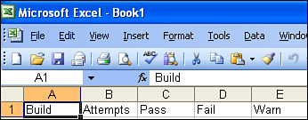

**Listing 12.34** Formatting the data

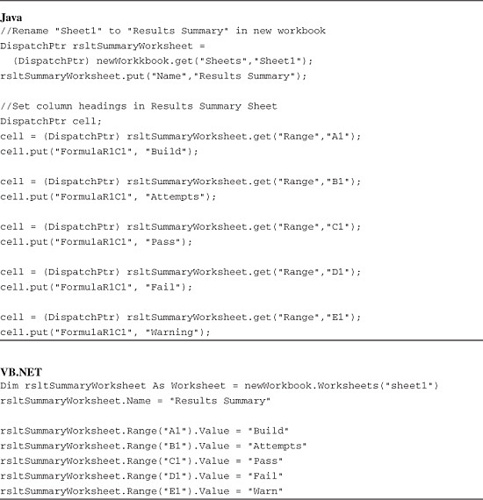

**The Build Results Utility Class**

Recall the results can be found in the resultsSheet object you created earlier. A utility class shown in [Listing 12.35](https://www.safaribooksonline.com/library/view/software-test-engineering/9780137036455/ch12.html#ch12ex35) will help you facilitate the tallying and summarization of these results. It is used to capture the build names found in the original results.txt file. It also encapsulates the methods for incrementing, calculating, and returning the number of execution attempts per build and the results per execution attempt.

**Listing 12.35** The Build Results Utility class

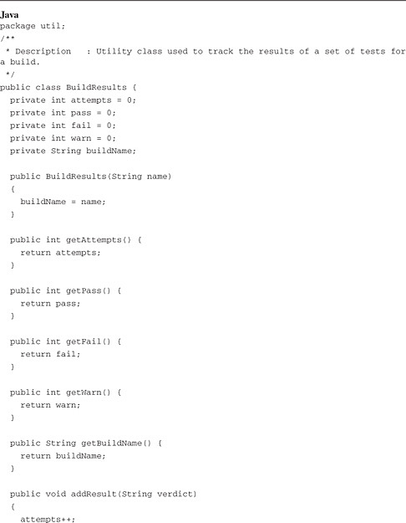

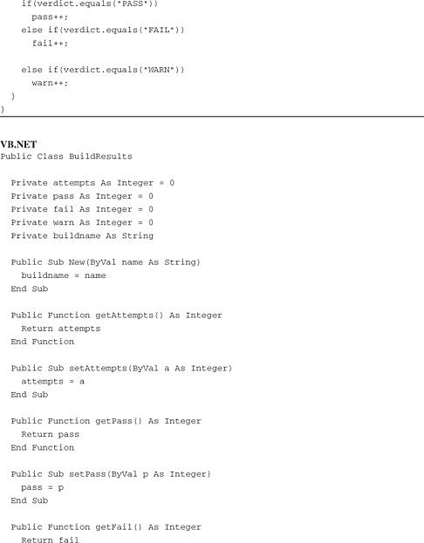

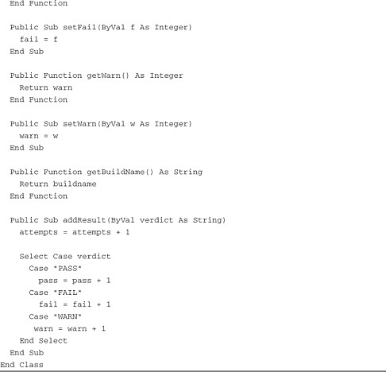

**Filtering results.txt by Build**

This BuildResults utility class is first used to filter the results.txt data by build. This is accomplished by iterating through a For loop, based off of the number of populated rows in the result worksheet (in the results.txt workbook). The build names are used as keys in a hashtable called resultsSummary. If a build name does not exist in the hashtable, it is added; otherwise, it is ignored. This prevents duplicate keys. The addResult() method, of the BuildResults class is then called to increment the number of passes, failures, and warnings found for each execution attempt per build. Refer to [Listing 12.36](https://www.safaribooksonline.com/library/view/software-test-engineering/9780137036455/ch12.html#ch12ex36).

**Listing 12.36** Filtering results.txt by build

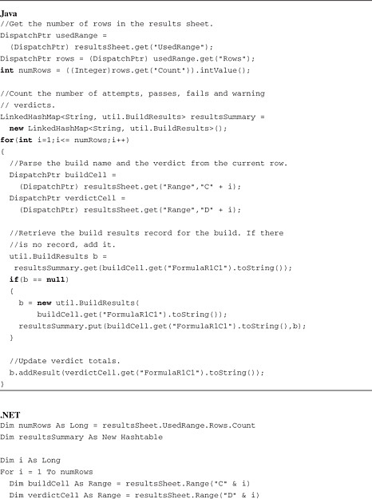

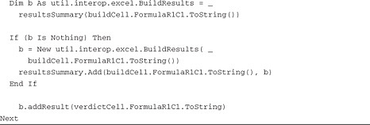

**Populating the Result Summary Sheet**

The utility class is then used within a While loop. The resultsSummary hashtable is revisited to acquire its values enumerator. This drives the number of iterations in the While loop. Each iteration solicits the BuildResults class, obtaining build names, execution attempts, and execution results. Refer to [Listing 12.37](https://www.safaribooksonline.com/library/view/software-test-engineering/9780137036455/ch12.html#ch12ex37).

**Listing 12.37** Populating the Result Summary sheet

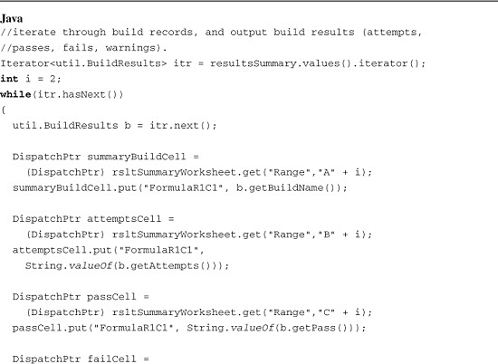

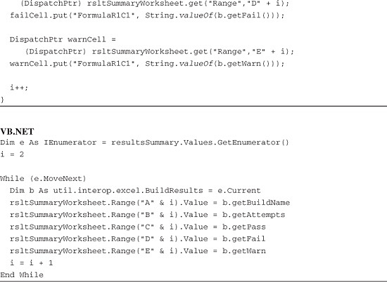

**Creating the Chart**

The last piece of this example, shown in [Listing 12.38](https://www.safaribooksonline.com/library/view/software-test-engineering/9780137036455/ch12.html#ch12ex38), is creating the chart. After selecting the cells that you populated in the results summary worksheet, you need to gain access to the charts collection in the first workbook you created (that is, newWorkbook). This collection enables you to add a new chart using its Add() method. You are allowed to specify the chart’s name, type, and whether it is plotted by columns or rows.

**Listing 12.38** Creating the chart

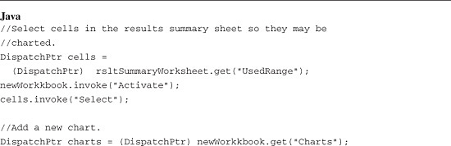

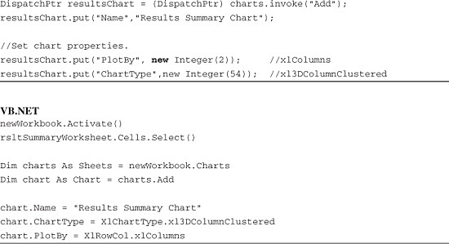

**Encapsulating Jawin Code in a Set of Classes**

Using Jawin to interface to a scriptable COM component from Java is powerful because the Jawin code is simple and generic. However, the code is so generic that it is ugly, difficult to understand, and difficult to maintain. One area of concern is the parameters passed to the methods in Excel are not type safe. It is recommended that you encapsulate the Jawin code in a set of wrapper classes, which in turn invoke Excel methods.

The Jawin project comes with an application called the TypeBrowser, which can be used to generate wrapper classes. You point it to a .dll or an executable and it produces the code. Refer to the TypeBrowser documentations for instructions to generate code to access Excel. The generated code is a useful starting point, but also has many issues:

• The generated code does not compile because there are many classes that are referenced, but not generated. There are also many instances where a class is defined as _ClassName, but referenced as Class (_Application vs Application). Finally, some methods use variables that are undefined.

• Many of the parameters to methods are of type Variant. Using this type is cumbersome and not beneficial in terms of maintaining type safety.

• Many of the method signatures include unnecessary parameters. The Excel Object Model has many methods with long lists of optional parameters. Although the API supports ignoring optional parameters, the generated code uses each one. The generated code for Workbooks.OpenText, for example, has 18 parameters (only 1 is required). Calling a method with this many parameters is ugly.

Despite all of the issues, using the generated code is much better than starting from scratch. After you understand the Jawin interface and the interface of the Com object you are interfacing to, it is a simple matter of altering the code to be more useful. As an example, [Listing 12.39](https://www.safaribooksonline.com/library/view/software-test-engineering/9780137036455/ch12.html#ch12ex39) is a Rational Functional Tester test script that accomplishes the same task as the previous simple example. This script uses classes that are generated using the TypeBrowser and then altered to correct the issues just described.

**Listing 12.39** Hello World Rational Functional Tester script using classes to encapsulate Jawin

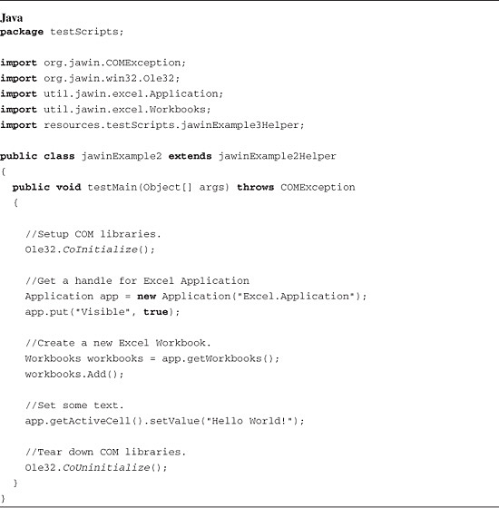

[Listing 12.40](https://www.safaribooksonline.com/library/view/software-test-engineering/9780137036455/ch12.html#ch12ex40) shows the Application class used in the jawinExample2 test script. Only the methods used in the test script are shown.

**Listing 12.40** The Application class

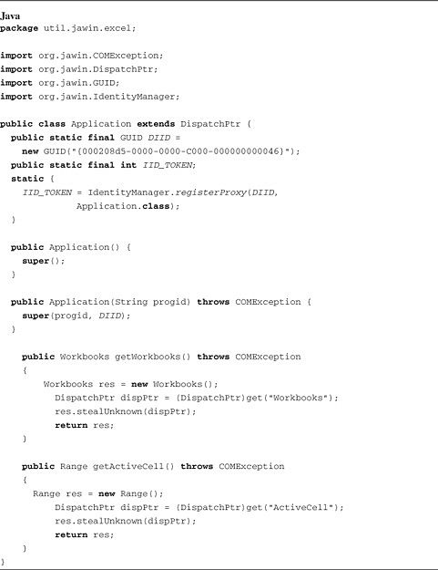

[Listing 12.41](https://www.safaribooksonline.com/library/view/software-test-engineering/9780137036455/ch12.html#ch12ex41) shows the Workbooks class used in the jawinExample2 test script. Only the methods used in the test script are shown.

**Listing 12.41** The Workbooks class

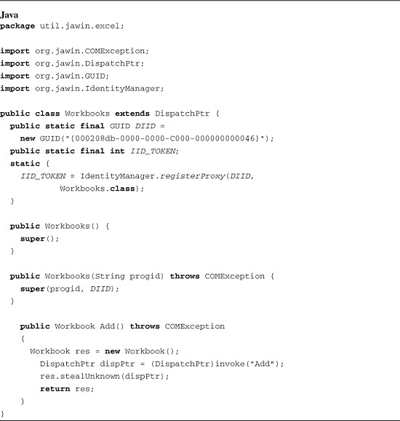

[Listing 12.42](https://www.safaribooksonline.com/library/view/software-test-engineering/9780137036455/ch12.html#ch12ex42) shows the Range class used in the jawinExample2 test script. Only the methods used in the test script are shown.

**Listing 12.42** The Range class

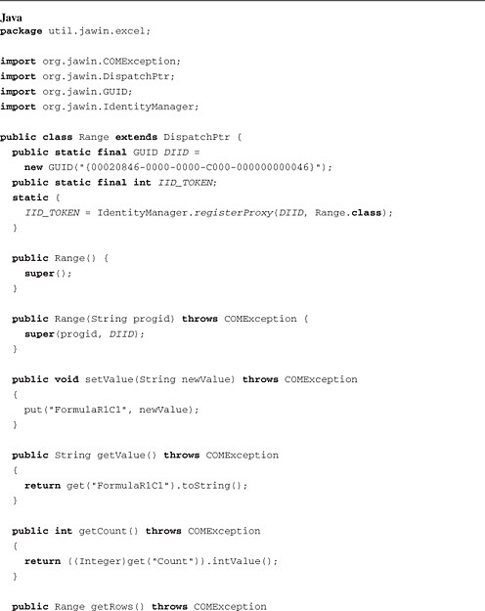

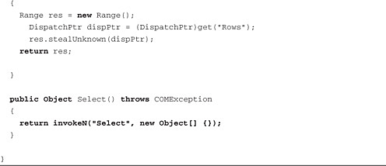

**Summary**

This chapter covers several examples of how you can extend the capability of Rational Functional Tester using existing external libraries. You now have an understanding of how you might use PDFBox to load a PDF file and extract the text from it. This extracted text is the basis for a custom verification point using the google-diff-match-patch library as the comparison algorithm. You learned how to create a logging framework that leverages the configuration capabilities of log4j and log4net. Finally, you learned how to interface to Excel to create a charting utility, which can be run from a Rational Functional Tester script. This utility reads the output from the logs in the logging example. You can run large sets of tests, and then execute the charting script to automatically create a chart suitable for your test report.

You can easily build on these examples to create powerful test automation capabilities. You can create a logging solution that sends logs to a central log server. You can create a framework for testing Excel-based applications. You can explore other pieces of PDFBox that you can take advantage of such as highlighting words, wrapping stripped text in simple HTML, and stripping text from a specified region. You might instead choose to work with other external libraries. The possibilities are endless.

[Prev](https://www.safaribooksonline.com/library/view/software-test-engineering/9780137036455/ch11.html)

[Chapter 11. Testing Specialized Applications](https://www.safaribooksonline.com/library/view/software-test-engineering/9780137036455/ch11.html)

[Next](https://www.safaribooksonline.com/library/view/software-test-engineering/9780137036455/ch13.html)

[Chapter 13. Building Support for New Objects with the Proxy SDK](https://www.safaribooksonline.com/library/view/software-test-engineering/9780137036455/ch13.html)

**Welcome to Safari**. Remember, your free trial will end on March 7, 2015, but you can [subscribe at any time](https://www.safaribooksonline.com/subscribe/)

* [Recommended](https://www.safaribooksonline.com/r/)
* [Queue](https://www.safaribooksonline.com/s/)
* [Recent](https://www.safaribooksonline.com/recent/)
* [Topics](https://www.safaribooksonline.com/t/)
* [Settings](https://www.safaribooksonline.com/u/)
* [Blog](http://blog.safaribooksonline.com/)
* [Support](http://support.safaribooksonline.com/?prod=flow)
* [Support](http://msupport.safaribooksonline.com/?prod=flow)
* [Feedback](mailto:feedback@safaribooksonline.com)
* [Sign Out](https://www.safaribooksonline.com/accounts/logout/)

© 2015 [Safari](http://www.safaribooksonline.com/).   
[Terms of Service](https://www.safaribooksonline.com/terms/) / [Membership Agreement](https://www.safaribooksonline.com/membership-agreement/) / [Privacy Policy](https://www.safaribooksonline.com/privacy/)

[**Make font larger Make font smaller**](https://www.safaribooksonline.com/library/view/software-test-engineering/9780137036455/ch12.html)